**Throw**

* Throw is used to throw predefined or user defined exception explicitly.

**Example**

class Main

{

public static void main(String args[])

{

try

{

int a = Integer.parseInt(args[0]);

int b = Integer.parseInt(args[1]);

if(b==0){

throw new ArithmeticException();

}

int res = a/b;

System.out.println("Result = "+res);

}

catch(ArithmeticException e)

{

System.out.println("Error : "+e);

}

System.out.println("Code..");

System.out.println("Code..");

System.out.println("Code..");

}

}

**Difference between throw and throws**

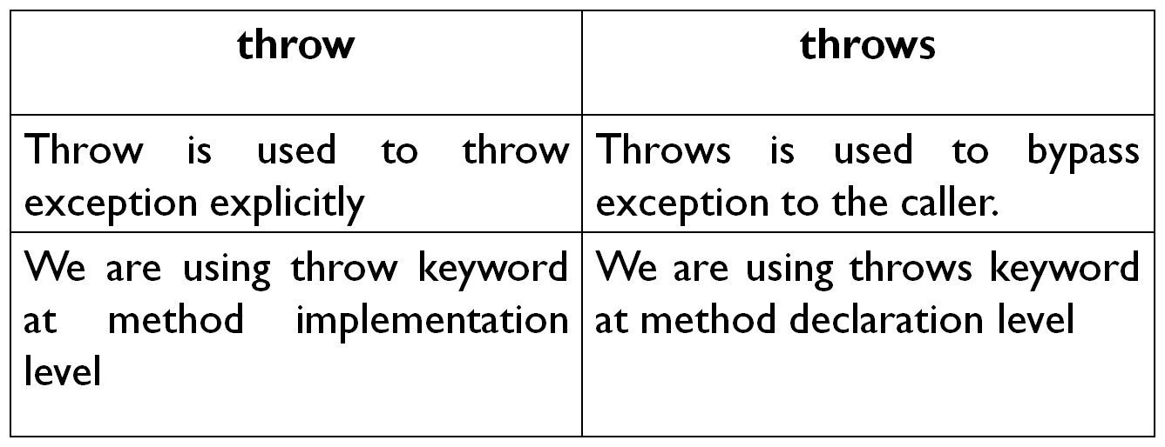

**StackOverFlowError**

class Main

{

static void display()

{

System.out.println("display...");

display();

}

public static void main(String args[])

{

display();

}

}

**OutOfMemoryError**

class Main

{

public static void main(String args[])

{

int arr[] = new int[1000000000];

}

}

**User defined exception**

Exceptions created by user are called user defined Exceptions.

class MyException extends Exception

{

MyException(String msg)

{

super(msg);

}

}

class Main

{

public static void main(String args[])

{

try

{

int age = Integer.parseInt(args[0]);

if(age<18)

{

throw new MyException("You are not eligible for voting");

}

System.out.println("You are eligible for voting");

}

catch(Exception e)

{

System.out.println(e.getMessage());

}

}

}

**Try with resource**

import java.io.*;

class Main

{

public static void main(String args[])

{

try(FileOutputStream fout =new FileOutputStream("data.txt")) {

fout.write("BBSR1".getBytes());

System.out.println("Date Saved..");

}

catch(Exception e)

{

System.out.println(e);

}

}

}